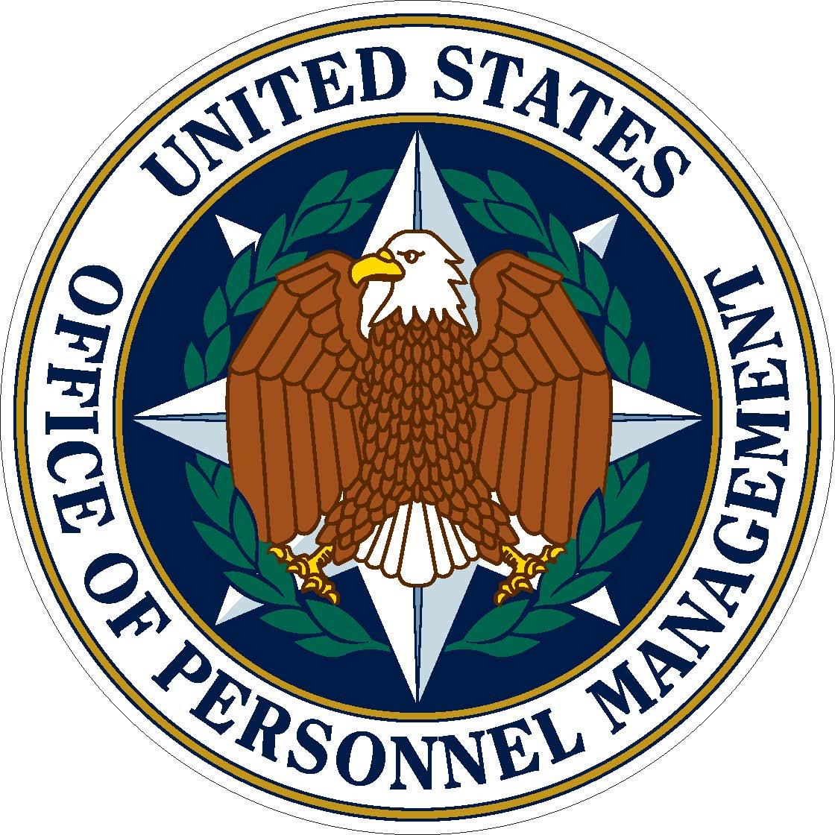

Get College Credit for Your FEMA Training

Excelsior College awards credit for Federal Emergency Management Agency (FEMA) training in two ways:

- You can receive credit for FEMA Independent Study (IS) courses that have been evaluated and approved by Frederick Community College (FCC). To see which courses qualify for credit and the number of credits per course, visit the Emergency Management Study printable course list.

The listing of courses at the top are each awarded one semester hour. If you scroll down, you'll also see listings for combined courses. To earn combined course credit, a student must have taken all of the FEMA IS courses in the specified combination to earn one semester hour. Excelsior will list the credit using the FCC course number and title, and will use the FEMA IS transcript as the official source of record. Students can use the course number to see if their course has a credit recommendation.

- The American Council on Education (ACE) has made credit recommendations for FEMA's National Emergency Training Center (NETC) courses. There are two series of courses evaluated by ACE: NETC Emergency Management Institute (EMI) and NETC National Fire Academy (NFA). These typically are not independent study courses. Students who have taken a course offered by NETC EMI or NETC NFA can either submit an ACE transcript or a transcript from NETC EMI or NETC NFA. The non-IS credits recommendations are offered through ACE and can be found through the ACE Credit Registry and Transcript System.

To learn more about the Federal Government Alliance with Excelsior, visit Feducation or call 844-843-9296. If you are a veteran or active duty military, call 844-843-9299. Remember that as a Federal Government employee, you and your spouse or partner receive discounted tuition and fees as well as the opportunity to defer tuition payment until your course is complete! Make sure to mention you are with the Federal Government to ensure you receive partnership discounts and other benefits.

Expect more. Get More.

